CHAPTER 8: The dynamic Earth
Worksheet 8.1

Continental drift
Answers

Two hundred million years ago
1. The map below shows the continents as they were 200 million years ago.
(a) Identify the name of the supercontinent that existed 225 million years ago before it broke up into Laurasia and Gondwana.
Pangaea
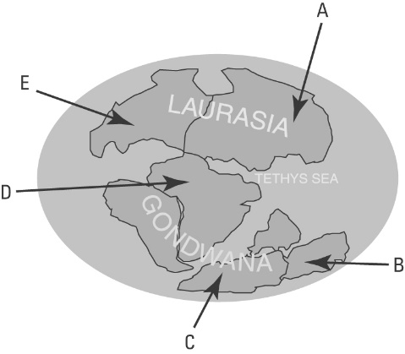 | (b) Identify the name of the continents of today that are labelled with the letters A–E.  Asia  A:  Australia  B:  Antarctica  C:  Africa  D:  North America  E:
(c) Fossils of a fern called Glossopteris have been found in the locations marked on the map below.
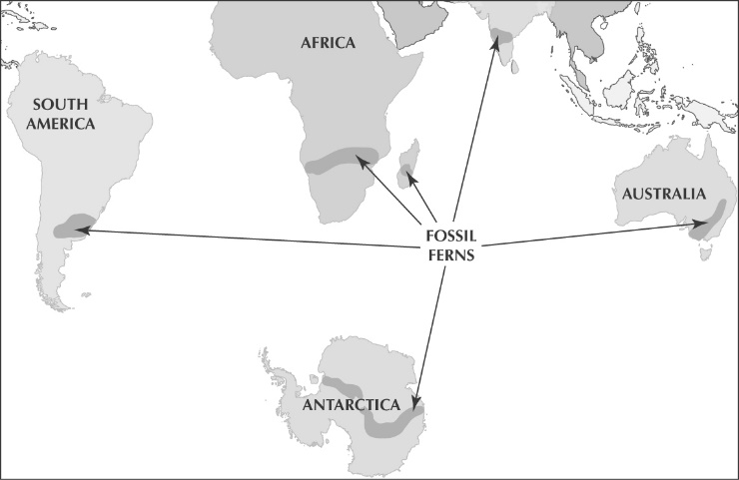  © MAPgraphics Pty Ltd, Brisbane | Explain how scientists use this information to support the theory of continental drift.  These continents were all once part of Gondwana, therefore the spores of the fern could be transported across the land in wind currents to colonise new areas. As Gondwana broke up and oceans separated the ferns, this process could no longer occur.

Alfred Wegener
2. During the late 1800s and early 1900s, scientists collected evidence that indicated that the continents were moving. In 1912, Alfred Wegener made a number of observations about continental drift.
(a) Explain what Wegener noticed about the shapes of coastlines of various continents such as Africa and South America.
The east coast of South America and the west coast of Africa fit together like a jigsaw. This suggests that these two continents were once joined and then split apart as continental drift occurred.

(b) Explain how fossils and rock types supported Wegener’s theory.
The occurrence of similar fossils and rock types on the margins of continents such as Africa and South America supported the theory that these continents were once joined.

